**Creating a Form in HTML**

The following HTML code allows you to create a form ready for user input. Examine the code and the comments in green as these explain the HTML for you.

<html>

<body>

<!--all HTML forms start with the FORM element-->

<form action="/myemailmessageform" method="post">

<!--We will now add our labels and text boxes (placed into divs so we have easy control over them for structuring and styling)-->

<div>

<legend>

Personal Information:

</legend>

</div>

<div>

<label for="name">Name:</label>

<input type="text" id="name" />

</div>

<!--Note the use of the for attribute on all <label> elements; it's a formal way to link a label to a form component.

It references the id of the corresponding component. It allows the user to click on the label to activate the corresponding component.

The type attribute on the input element defines the way it behaves. Text is the default which accepts single line text without any validation-->

<div>

<label for="mail">E-mail: </label>

<input type="email" id="mail" />

</div>

<div>

<label for="mail">Re-Enter Email: </label>

<input type="email" id="mail2" />

</div>

<div>

<label for="password">Password: </label>

<input type="text" id="password" />

</div>

<div>

<label for="password">Re-Enter Password: </label>

<input type="text" id="password2" />

</div>

<!--We also use the type email that defines a single-line text field that will perform some checks on the data typed by the user. -->

<div>

<label for="msg">Message:</label>

<textarea id="msg"> "Hello, it's me!"</textarea>

</div>

<div class="button">

<button type="submit">Create An Account</button>

</div>

<!--note the syntax for the message - rather than input, we have textarea and when using this we have to add the closing tag.-->

</form>

</body>

</html>

**Task 1**

Copy the code into Notepad++ and save as .htm file.

All this lovely html above will only create this:

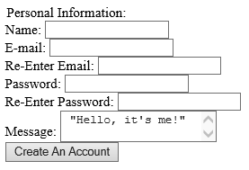

**Task 2**

This needs some formatting and therefore needs to link to a CSS sheet. Enter the appropriate line in HTML that will link to the Form CSS file you have been given on the VLE.

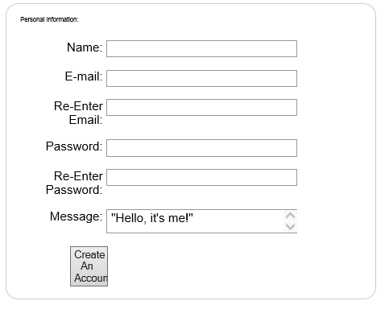**Task 3**

You will see that the formatting is much better, but not quite as we would like it as there are some sizing issues.

**Task 4**

See if you can amend the style sheet to give a better result like the one show below:

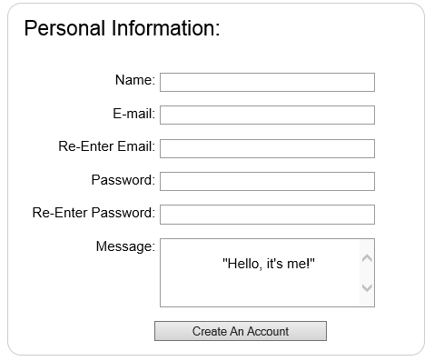

**Task 5**

We now want to place our form inside one of the <div>s we formatted earlier – something like this:

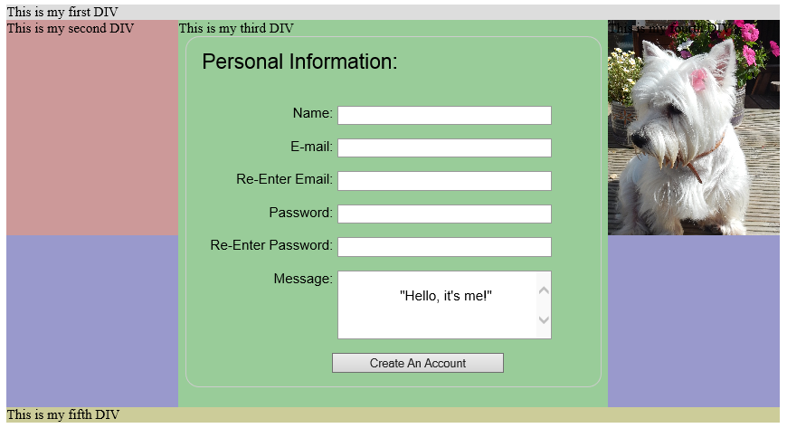

In order to do this, you need to copy the html code for the form and insert it into the html code for the <div> you want to place it into.

You will then need to include another link to the form CSS file to add the formatting for the form.

You fill find that the form will not fit your <div>

Alter the CSS to make it fit nicely.